|  |  |  |  |  |
| --- | --- | --- | --- | --- |
|  |  | | | |
|  | |  | | |
| Project: | | Auto-Learn | | |
| Team No.: | | Team 2 | | |
| Class: | | CSE 3310.004 - Spring 2020 | | |
| Module: | | System Requirements Analysis (SRA) | | |
| Deliverable: | | SRA Document | | |
| Version: | | [1.5] | Date: | [03/31/2020] |

Contributors:

Edrik Aguilera

William Anderson

Ryan Laurents

Jonathan Padilla

Revision History

| Version number | Date | Originator | Reason for change | High level description of changes |
| --- | --- | --- | --- | --- |
| 1.0 | 03/05/2020 | Edrik Aguilera  William Anderson  Ryan Laurents  Jonathan Padilla | Initial draft |  |
| 1.1 | 03/09/2020 | Ryan Laurents | Section 4 | Added System requirements |
| 1.2 | 03/23/2020 | Edrik Aguilera | Section 5 | Conceptual data model added |
| 1.3 | 03/25/2020 | Edrik Aguilera  William Anderson | Section 5 and 3 | CDM updated, context diagram added |
| 1.4 | 03/27/2020 | Edrik Aguilera  William Anderson | Section 2 updated,  Section 3 updated | Context diagram updated, additional business and system requirements added |
| 1.5 | 03/28/2020 | William Anderson | Convert to docx | Move SRA from Google Docs to Microsoft Word |
| 1.6 | 04/26/2020 | Ryan Laurents | Update changes | Updating changes to prep for the final binder. |

TABLE OF CONTENTS

1. Introduction and Project Overview 3

2. Objectives 4

2.1 BUSINESS Objectives 4

2.2 SYSTEM Objectives 5

3. Project Context Diagram 6

4. Systems Requirements 7

4.1 “Login” Requirements 7

4.2 “Home Screen” Requirements 11

4.3 “Menu” Requirements 13

4.4 “Profile” Requirements 17

4.5 “Take Photo” Requirements 21

4.6 “Choose from Gallery” Requirements 22

4.7 “Classification” Requirements 23

5. Software Processes and Infrastructure 24

5.1 Hardware and Infrastructure 24

5.2 UML Diagrams 25

5.3 Conceptual Data Model - Database 25

5.4 Screen Shots 25

5.5 Test Plan 25

6. Assumptions and Constraints 26

6.1 ASSUMPTIONS 26

6.2 CONSTRAINTS 26

6.3 Out of Scope material 26

7. Delivery and Schedule 27

8. Stakeholder Approval Form 28

Appendix: 29

# 1. Introduction and Project Overview

Team 2 has been employed to design and implement a software application for vehicle recognition. This Android application should allow their customers to upload their own photo or allow for a photo to be taken using the camera. The system will be up and operational during the last week of April 2020 just in time for new vehicles coming out for the 2021 model year. In addition to the minimum set of requirements listed below, Auto-Learn is open to any suggestions that end-users would like to see implemented in the app.

# 2. Objectives

## 2.1 BUSINESS Objectives

The following is a list of business objectives:

**Objective 1**: Member Registration: All members must provide the following information prior to using the system:

* First Name, Last Name
* UTA ID
* Email address
* Password
* Student or Teacher role

**Objective 2**: Login functionality: All members must login to the system with a user/password that was established during Member registration stage.

**Objective 3**: “Account Maintenance” functionality must be supported that allows user to close account and edit personal information and includes the following customer data:

* Email address
* Password
* Delete Account

**Objective 4**: The user can request classification of up to six different types of Vehicles:

* SUV
* Truck
* Coupe
* Convertible
* Sedan
* Van

**Objective 5:** The user must be able to view data and statistics of each classification.

**Objective 6:** The user must be able to upload their own photo of a vehicle or take a photo using the device’s camera.

**Objective 7:** The user must be able to recover their password or username in the event of

unauthorized access or loss of credentials.

.

## 2.2 SYSTEM Objectives

The following is a list of system objectives:

**Objective 1**: System will be an Android application

**Objective 2**: Python/Tensorflow will be used to implement machine-learning.

**Objective 3:** Firebase will be used to manage login credentials and the mobile ML model.

**Objective 4:** Java will be used in conjunction with Android Studio in order to develop the

UI of the app.

**Objective 5:** Google’s Material Design will be used as the UI theme of the app

**Objective 6:** App will save data and results for 6 different classifications to keep data persistent only until the app closes

# 3. Project Context Diagram

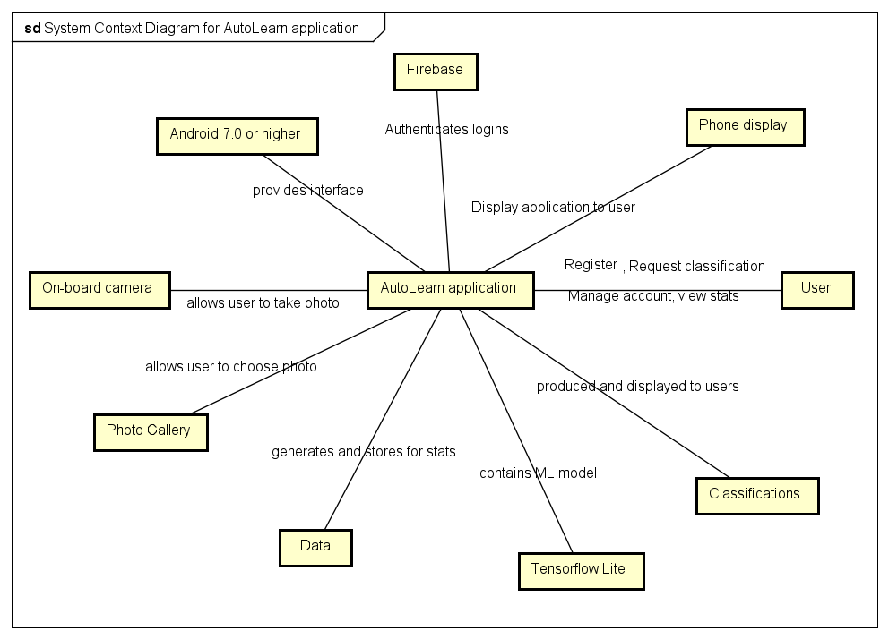

# 4. Systems Requirements

## 4.1 “Login” Requirements

|  |  |
| --- | --- |
| **Requirement Title:** | Sign Up |
| **Sequence No:** | 01 |
| **Short description:** | Allow a new user to sign up for an account. |
| **Description:** | The “Sign Up” button will be located near the bottom of the login screen. Clicking the button will take the user to an Account Creation page. The user will be prompted for the following information:   * Email Address * UTA ID * Password * Confirm Password * Student/Professor |
| **Pre-Conditions**: | The user has successfully downloaded the AutoLearn app from the Google Play store and has launched the app. |
| **Post Conditions:** | Logs in the user and navigates them to the home page. The system will automatically send the user a confirmation email to the email address they provided upon signing up. |
| **Other attributes:** | The login system will error check the password and confirm password fields to ensure that they match. The system will also check to make sure the email address entered is a valid email address. |

|  |  |
| --- | --- |
| **Requirement Title:** | Login |
| **Sequence No:** | 02 |
| **Short description:** | Allow a user to log into their account. |
| **Description:** | The login page will display an “Email” entry field and a “Password” entry field. The user can type in their email address and password they provided upon signing up to login to their account. |
| **Pre-Conditions**: | The user has successfully downloaded the AutoLearn app from the Google Play store and has launched the app. |
| **Post Conditions:** | Logs in the user and navigates them to the home page. |
| **Other attributes:** | The login system will check the email and password to make sure they match a corresponding profile in the database. |

|  |  |
| --- | --- |
| **Requirement Title:** | Forgot Password |
| **Sequence No:** | 03 |
| **Short description:** | Allow a user to request a password reset. |
| **Description:** | There will be a “Forgot Password?” button at the bottom of the login screen. Clicking this button will prompt the user for their email address. The system will then reset the password for the account associated with that address and send an email to the user with the new password. |
| **Pre-Conditions**: | The user has successfully downloaded the AutoLearn app from the Google Play store and has launched the app. The user must already have an account with AutoLearn. |
| **Post Conditions:** | The user will stay on the login screen and can enter their new password to gain access to their account. |
| **Other attributes:** | The system will send the confirmation email for the password reset to the user. The email will contain a link for a password reset. |

|  |  |
| --- | --- |
| **Requirement Title:** | AutoLearn Logo |
| **Sequence No:** | 04 |
| **Short description:** | Display the AutoLearn logo on the splash screen before the login screen shows. |
| **Description:** | The splash screen will display the name AutoLearn and the logo before displaying the login screen. |
| **Pre-Conditions**: | The user has successfully downloaded the AutoLearn app from the Google Play store and has launched the app. |
| **Post Conditions:** | N/A |
| **Other attributes:** | N/A |

## 4.2 “Home Screen” Requirements

|  |  |
| --- | --- |
| **Requirement Title:** | Home Screen |
| **Sequence No:** | 01 |
| **Short description:** | The home screen is the central hub for all the actions a user can take inside AutoLearn. |
| **Description:** | The home screen will display buttons that navigate to all of the subsections of the app. If the user does not have any classifications yet, the home screen will display “To get started upload a photo or take a photo” After completing one classification, the home screen will display a “View Results” button. The subsections shown as buttons are the following:   * Settings (In the top left) * Statistics (In the top right) * Take Photo/Choose from Gallery (In the bottom right) |
| **Pre-Conditions**: | The user must successfully login to their user account. |
| **Post Conditions:** | N/A |
| **Other attributes:** | N/A |

|  |  |
| --- | --- |
| **Requirement Title:** | Statistics |
| **Sequence No:** | 02 |
| **Short description:** | Statistics button will take the user to a stats page |
| **Description:** | When the user first launches the app and creates a profile, there will be no statistics to show. Instead there will be a message to the user to try out the classification service first. Once the first classification has been done, the user will be able to click the stats button in the top right. Statistics such as the following will be shown:   * Accuracy * Average time to classify   Since accuracy will rely on the user to give us that information, there will be a pop-up after each classification asking if the information was correct. That response will go into the accuracy section of the statistics. |
| **Pre-Conditions**: | The user must be logged in to their account and have performed at least one classification. |
| **Post Conditions:** | N/A |
| **Other attributes:** | N/A |

## 4.3 “Menu” Requirements

|  |  |
| --- | --- |
| **Requirement Title:** | Menu |
| **Sequence No:** | 01 |
| **Short description:** | The settings tab will show information about the app as well as some app-based settings options. |
| **Description:** | Pressing the settings button (3 horizontal lines) on the top left of the home screen will expand the settings menu. Within the settings menu there will be several options:   * Account Settings * Model Information * Log out |
| **Pre-Conditions**: | The user must be logged in to their account and have pressed the menu button on the home screen. |
| **Post Conditions:** | The menu will expand out from the left side of the screen. |
| **Other attributes:** | N/A |

|  |  |
| --- | --- |
| **Requirement Title:** | Profile Picture |
| **Sequence No:** | 02 |
| **Short description:** | The user can change their profile picture by clicking the icon in the top left of the menu. |
| **Description:** | Pressing the profile picture icon will prompt the user with several options:   * Take Photo * Choose from Gallery * Cancel   The user may choose the appropriate option to update their profile picture to their liking. |
| **Pre-Conditions**: | The user must be logged in to their account and have pressed the menu button on the home screen. |
| **Post Conditions:** | The menu will expand out from the left side of the screen. |
| **Other attributes:** | N/A |

|  |  |
| --- | --- |
| **Requirement Title:** | Account Settings |
| **Sequence No:** | 03 |
| **Short description:** | Allow the user to change personal information related to their account. |
| **Description:** | Pressing the account settings button will take the user to a new screen that will allow them to change their email, change their password, or delete their account. |
| **Pre-Conditions**: | The user must be logged into their account. The user must have also pressed the menu button as well as the account settings button within that menu. |
| **Post Conditions:** | The user will be back at the home screen after updating their information. |
| **Other attributes:** | N/A |

|  |  |
| --- | --- |
| **Requirement Title:** | Model Information |
| **Sequence No:** | 04 |
| **Short description:** | The “Model Information” button will show info on the creation of the model used for classification. |
| **Description:** | Pressing the model information button will bring the user to an info screen. The information will include:   * Average Precision * Recall Percentage * Latency * 6 classes of vehicles * Number of images used to train and test the model |
| **Pre-Conditions**: | The user must be logged into their account. They must also press the settings menu button as well as the model information button. |
| **Post Conditions:** | The user will be back on the home screen when done. |
| **Other attributes:** | N/A |

|  |  |
| --- | --- |
| **Requirement Title:** | Log Out |
| **Sequence No:** | 05 |
| **Short description:** | Press the log out button to log out of your account. |
| **Description:** | Pressing this button will log out of the users account and return them to the launch screen. |
| **Pre-Conditions**: | The user must be logged into their account. They must also press the menu button and hit “Log Out” within that menu. |
| **Post Conditions:** | The user will be navigated to the launch screen. |
| **Other attributes:** | N/A |

## 4.4 “Account Settings” Requirements

|  |  |
| --- | --- |
| **Requirement Title:** | Change Password |
| **Sequence No:** | 01 |
| **Short description:** | This function allows the user to change their password. |
| **Description:** | Due to the sensitive nature of a password, it will not be visible on the profile page. To change or update your password you must hit the “Change Password” button located on the account settings page. When pressed, the user will be navigated to a Change Password page. The page wiill ask you for your current password and to confirm that password. If both entry fields match each other as well as the database information and the “Enter” button is pressed, the password will be updated. |
| **Pre-Conditions**: | The user must be logged in to their account and have pressed the menu button on the home screen. They must also press the account settings page, then the “Change Password” button. |
| **Post Conditions:** | When the user has completed the prompts for changing password, they will be back on the home screen. |
| **Other attributes:** |  |

|  |  |
| --- | --- |
| **Requirement Title:** | Change Email |
| **Sequence No:** | 02 |
| **Short description:** | This function allows the user to change their email address. |
| **Description:** | To change or update your email you must hit the “Change Email” button located on the Account Settings menu. When pressed, the user will be taken to a “Change Email” page. The user will then be prompted to enter their desired email address in the input box. Once completed, they may hit the “Verify Email” button on screen to send a verification email to their new email address. |
| **Pre-Conditions**: | The user must be logged in to their account and have pressed the menu button on the home screen. They must also press the account settings page, then the “Change Email” button. |
| **Post Conditions:** | When the user has completed the prompts the will be back on the home screen. |
| **Other attributes:** | The system will send a verification email to the new email address to confirm that the email change has taken effect. |

|  |  |
| --- | --- |
| **Requirement Title:** | Delete Account |
| **Sequence No:** | 03 |
| **Short description:** | This function allows the user to delete their account. |
| **Description:** | Pressing the “Delete Account” button will prompt the user with “Are you sure?” There will be a “Cancel” and “DELETE” button on the bottom of the prompt. Pressing the cancel button will return them to the home screen. Pressing the delete button will return them to the login page. |
| **Pre-Conditions:** | The user must be logged in to their account and have pressed the menu button on the home screen. They must also press the account settings page, then the “Delete Account” button. |
| **Post Conditions:** | The user will be navigated back to the launch screen or the home screen depending on their decision. |
| **Other attributes:** | The users account information will be deleted. |

## 4.5 “Take Photo” Requirements

|  |  |
| --- | --- |
| **Requirement Title:** | Take Photo |
| **Sequence No:** | 01 |
| **Short description:** | Pressing the “Take Photo” button will open the users camera to take a new photo for classification. |
| **Description:** | The “Take Photo” button will have a picture of a camera on it and will be located in the bottom left of the home screen. Pressing this button for the first time will ask the user for permission/access to the camera. If permission is given, the camera application will open. Once a photo is taken the classification process will start automatically. |
| **Pre-Conditions**: | The user must be logged in to their account. |
| **Post Conditions:** | The classification process starts immediately after taking a picture. |
| **Other attributes:** | Must prompt the user for permissions to access the camera. |

## 4.6 “Choose from Gallery” Requirements

|  |  |
| --- | --- |
| **Requirement Title:** | Choose from Gallery |
| **Sequence No:** | 01 |
| **Short description:** | The “Choose from Gallery” button will open the user’s gallery to select a photo to upload. |
| **Description:** | Pressing this button for the first time will ask the user for permission/access to the gallery. If permission is given, the user will be taken to the gallery. They will be able to navigate their folders to select one (1) image to submit for classification. Once they select an image, the classification will automatically begin. |
| **Pre-Conditions**: | The user must be logged in to their account. |
| **Post Conditions:** | The classification process starts immediately after uploading a photo. |
| **Other attributes:** | Must prompt the user for permissions to access the gallery. |

## 4.7 “Classification” Requirements

|  |  |
| --- | --- |
| **Requirement Title:** | Classification |
| **Sequence No:** | 01 |
| **Short description:** | The classification process will use the machine learning model to determine the make/model of the vehicle in question. |
| **Description:** | Immediately after the user either takes a new photo with their camera or uploads a photo from their gallery, the classification process will begin. The photo will be input into the machine learning model. When the model is done with the classification process, the results will be shown to the user. The results will be shown as six percentages (one for each class) and the percentage of each that the model guesses for the corresponding picture. |
| **Pre-Conditions**: | The user must be logged in to their account and upload a photo via “Take Photo” or “Choose from Gallery.” |
| **Post Conditions:** | The user will end on the home screen. |
| **Other attributes:** | N/A |

# 5. Software Processes and Infrastructure

## 5.1 Hardware and Infrastructure

Android 7.0 Nougat and higher

Android SDK

Java Development Kit

Android Studio 3.6

Android Emulator / Google Pixel 3XL

Anaconda 2019.10 / Python 3.7

Jupyter Notebook

Tensorflow 2.1

Google Firebase

## 5.2 UML Diagrams

Please refer to Section 1 of the project binder. Original UML diagrams shown there.

## 5.3 Conceptual Data Model - Database

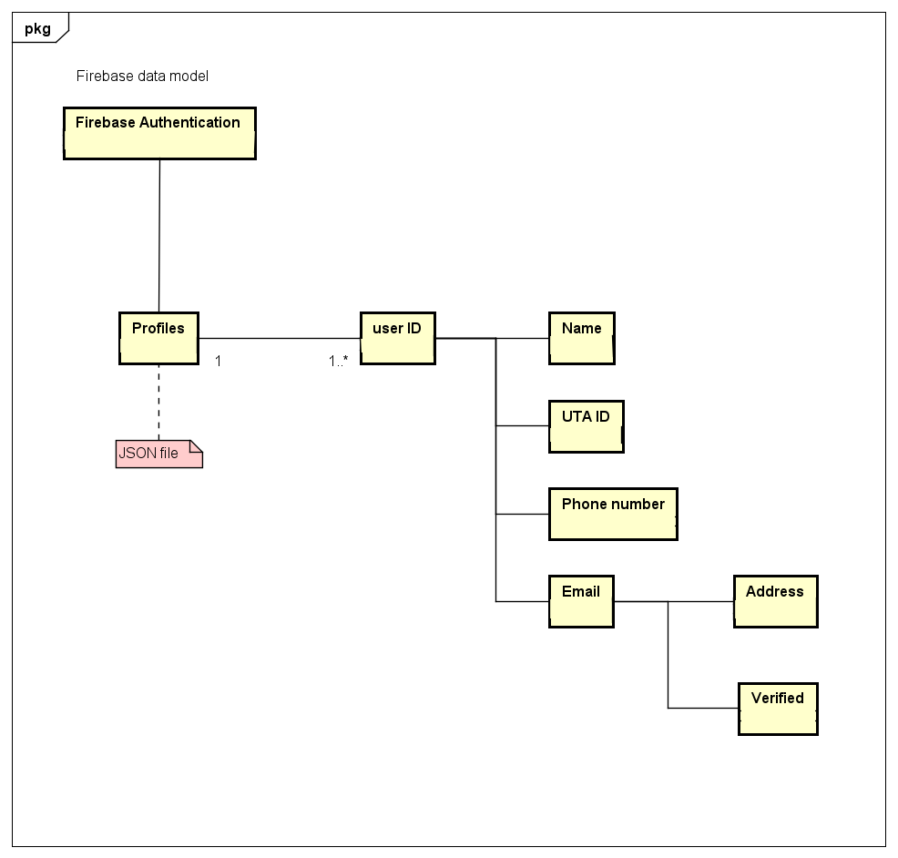

## 5.4 Screen Shots

None available at this time

## 5.5 Test Plan

The test plan can be viewed in the Team2_TPL_33104_Spring2020 file OR in the next section of the team binder.

# 6. Assumptions and Constraints

## 6.1 ASSUMPTIONS

The following is a list of assumptions:

* Ignore collecting money from external advertisement and general accounting
* Ignore compliance issues
* Ignore market conditions and demands
* Ignore future system additions

## 6.2 CONSTRAINTS

The following is a list of constraints:

* Team lacks Android experience
* Schedule very aggressive
* Team lacks TensorFlow experience
* Team lacks Python experience
* Team has very limited Java experience

## 6.3 Out of Scope material

The following is a list of “out of scope” material:

* Post Project maintenance is not covered

# 7. Delivery and Schedule

|  |  |  |  |  |
| --- | --- | --- | --- | --- |
| Task/Milestone Description | Anticipated Start Date | Anticipated End Date | Status | Comments |
| Prepare Requirements and UML diagram | 01/31/2020 | 02/21/2020 | Complete | Deliverable will be UL document.  Increment 1 Deliverable |
| SRA document (Includes project objectives, Requirements and UML diagrams) | 03/05/2020 | 03/31/2020 | Complete | Deliverable will be the SRA document. All stakeholders agree on the content of the SRA by signing in section 8.  Increment 2 Deliverable |
| Home screen design and implementation | 3/31/2020 | 04/02/2020 | Complete |  |
| Login and registration design and implementation | 03/31/2020 | 04/02/2020 | Complete |  |
| Set up Jupyter notebook for ML model | 03/31/2020 | 04/02/2020 | Complete |  |
| Import all necessary imports into Jupyter | 03/31/2020 | 04/02/2020 | Complete |  |
| Test case design | 03/31/2020 | 04/16/2020 | Complete | Increment 3 Deliverable |
| External Documentation (i.e. User Manual) | 04/20/2020 | 04/20/2020 | Complete |  |
| Project presentation | 04/28/2020 | 04/28/2020 | Complete |  |
| Final Milestone: project delivery |  | 4/30/2020 | Complete | Increment 4 Deliverable |

# 8. Stakeholder Approval Form

|  |  |  |  |
| --- | --- | --- | --- |
| Stakeholder Name | Stakeholder Role | Stakeholder Comments | Stakeholder Approval Signature and Date |
| Rodrigo Augusto | Development Mgr. |  |  |
| Tianhao Li | Project Assistant |  |  |
| Edrik Aguilera | Developer |  |  |
| William Anderson | Developer |  |  |
| Ryan Laurents | Developer |  |  |
| Jonathan Padilla | Developer |  |  |

# Appendix:

None